**java_springboot_restful_33_AlbumController – Upgrade View Albums API**

**Upgrading of listing all the albums API – How to get list of photos**

**Updated albums method**

 // List all the albums based on the logged in users

    @GetMapping(value = "/albums", produces = "application/json")

    @ApiResponse(responseCode = "200", description = "List of albums")

    @ApiResponse(responseCode = "401", description = "Token missing")

    @ApiResponse(responseCode = "403", description = "Token Error")

    @Operation(summary = "List album api")

    @SecurityRequirement(name = "studyeasy-demo-api")

    public List<AlbumViewDTO> albums(Authentication authentication) {

        String email = authentication.getName();

        Optional<Account> optionalAccount = accountService.findByEmail(email);

        Account account = optionalAccount.get();

        List<AlbumViewDTO> albums = new ArrayList<>();

        for (Album album : albumService.findByAccount_id(account.getId())) {

            List<PhotoDTO> photos = new ArrayList<>();

            for(Photo photo : photoService.findByAlbumId(album.getId())){

                String link = "/albums/"+album.getId()+"/photos/"+photo.getId()+"/download-photo";

                photos.add(new PhotoDTO(photo.getId(), photo.getName(), photo.getDescription(), photo.getFileName(),link));

            }

            albums.add(new AlbumViewDTO(album.getId(), album.getName(), album.getDescription(), photos));

        }

        return albums;

    }

**Updated AlbumViewDTO.java**

package org.studyeasy.SpringRestdemo.payload.album;

import java.util.List;

import io.swagger.v3.oas.annotations.media.Schema;

import io.swagger.v3.oas.annotations.media.Schema.RequiredMode;

import jakarta.validation.constraints.NotBlank;

import lombok.AllArgsConstructor;

import lombok.Getter;

import lombok.NoArgsConstructor;

import lombok.Setter;

import lombok.ToString;

@Getter

@Setter

@ToString

@NoArgsConstructor

@AllArgsConstructor

public class AlbumViewDTO {

    private long id;

    @NotBlank

    @Schema(description = "Album name", example = "Travel", requiredMode = RequiredMode.REQUIRED)

    private String name;

    @NotBlank

    @Schema(description = "Description for the Album", example = "description", requiredMode = RequiredMode.REQUIRED)

    private String description;

    private List<PhotoDTO> photos;

}

**Change the Structure**

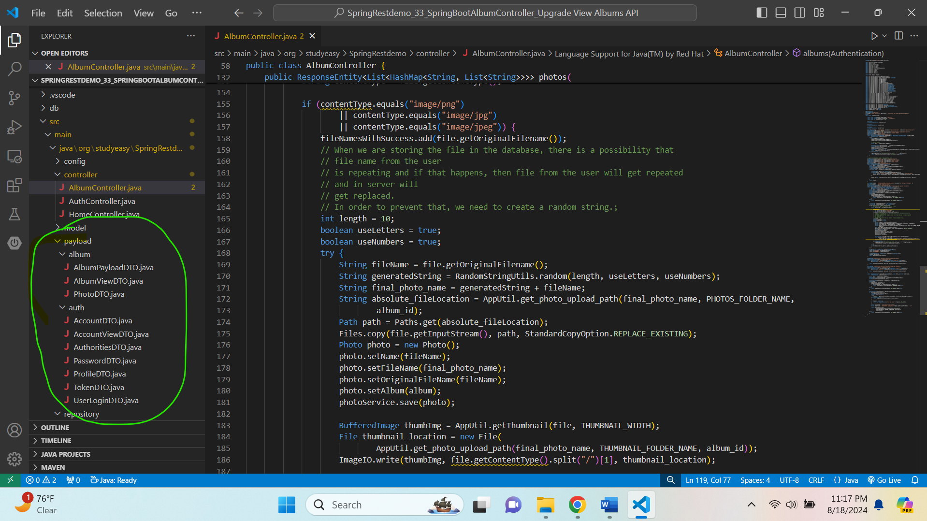

**Add a DTO in payload -> album -> PhotoDTO.java**

package org.studyeasy.SpringRestdemo.payload.album;

import lombok.AllArgsConstructor;

import lombok.Getter;

import lombok.NoArgsConstructor;

import lombok.Setter;

import lombok.ToString;

@Setter

@Getter

@ToString

@AllArgsConstructor

@NoArgsConstructor

public class PhotoDTO {

    private long id;

    private String name;

    private String desciption;

    private String fileName;

    private String download_link;

}

**Add below code in PhotoService.java**

public List<Photo> findByAlbumId(long id){

        return photoRepository.findByAlbum_id(id);

    }

**Add this code in PhotoRepository.java**

List<Photo> findByAlbum_id(long id);